Graduate Management Information System
研究生管理信息系统

User
Manual
for
International
Student
留
学
生
端
操
作
手
册

Content
目 录
1 User Login 1
1用户登录 1
2 Public information 2
2公共信息 2
2.1 Master Training Program 2
2.1学历硕士培养方案 2
2.2 Doctoral Training Program 3
2.2学历博士培养方案 3
2.3 Professional Master Training Program 3
2.3专业学位培养方案 3
2.4 Course Arrangement Information 4
2.4课程排课信息一览 4
2.5 Course Outline Query 4
2.5 课程大纲查询 4
2.6 Check Announcement 4
2.6通知公告查询 4
3 Personal Information 5
3个人信息 5
3.1 Student Semester Registration 5
3.1学生学期注册 5
3.2 Basic Personal Information 6
3.2个人基本信息 6
3.3 Personal Information Editing 7
3.3个人信息修改 7
3.4 Application for Personal Key Information Modification 7
3.4个人关键信息修改申请 7
3.5 Status-Change Application 8
3.5学籍异动申请 8
3.6 Postgraduate Enrollment Registration 8
3.6研究生入学登记 8
3.7 Modification for Login Password 9
3.7登陆密码修改 9
3.8 Photo Information Check 9
3.8照片信息核对 9
3.9 Registration for Grade Examination 10
3.9等级考试报名 10
3.10 Grade Examination Results Query 10
3.10等级考试成绩查询 10

4 Training Management 12
4培养管理 12
4.1 Teaching Plan Submission 12
4.1提交教学计划 12
4.2 Teaching Plan Query 14
4.2教学计划查询 14
4.3 Course Query 15
4.3开课目录查询 15
4.4 School Timetable Query 15
4.4全校课表查询 15
4.5 Course Exemption Application 15
4.5课程免修申请 15
4.6 Courses Online Selection 16
4.6学生网上选课 16
4.7 Course Selection Result Query 16
4.7选课结果查询 16
4.8 Personal Timetable Query 17
4.8学生课表查询 17
4.9 Personal Score Query 18
4.9学生成绩查询 18
4.10 Social Practice Registration 18
4.10社会实践登记 18
4.11 Teaching Practice Registration 19
4.11教学实践登记 19
4.12 Input of Comprehensive Examination Score for PhD Student 19
4.12 博士综合考试成绩录入 19
4.13 Academic Activity Registration 19
4.13学术活动登记 19
4.14 Academic Report Registration 20
4.14做学术报告登记 20
4.15 Literature Reading Report Registration 20
4.15文献阅读报告登记 20
4.16 Mid-term Evaluation Registration 20
4.16中期考核登记 20
4.17 Course Adjustment and Suspension Information Query 21
4.17调停课信息查询 21
5 Graduation and Degree 22
5毕业与学位 22
5.1 Registration of Published Papers 22
5.1发表论文登记 22
5.2 Registration of Scientific Research Projects 22
5.2科研项目登记 22
5.3 Patent Registration 23
5.3专利情况登记 23
5.4 Awarding Registration 23
5.4获奖情况登记 23
5.5 Registration of Research Achievement 24
5.5研究成果登记 24
5.6 Opening Report Application 24
5.6开题报告申请 24
5.7 Opening Report Result Input 25
5.7开题结果录入 25
5.8 Application for Changing Research Topic 25
5.8 学生换题申请 25
5.9 Pre-defense for PhD Student 25
5.9 博士预答辩 25
5.10 Application for Dissertation Repetition Rate Query 26
5.10 论文查重申请 26
5.11 Result of Dissertation Repetition Rate Query 26
5.11 论文查重结果 26
5.12 Registration for Dissertation Blind Review 27
5.12 学生盲审登记 27
5.13 Result of Dissertation Blind Review 27
5.13学生盲审查询 27
5.14 Verification of Degree Conferring Data 28
5.14学位授予数据核对 28
5.15 Application for Final Defense 28
5.15学生答辩申请 28
5.16 Submission of Final Dissertation 29
5.16上传答辩学位论文 29
5.17 Application for Early Graduation 29
5.17 提前毕业申请 29
5.18 Application for Postponing Graduation 30
5.18 延期毕业申请 30
5.19 Personal Files Query 30
5.19 学生档案材料查询 30
6 Project Application 31
6 项目申请 31
6.1 Application for Provincial Innovation Plan 31
6.1 省创新计划申请 31

1 User Login

1用户登录
Function: Student login system.
功能说明:学生端登陆系统。
Instructions: Enter the url (https://gs.njfu.edu.cn/pyxx_nl_en/login.aspx), and enter the login interface as shown in Figure 1.1, then enter the user name (student number), password (passport number or previous passport number when you admitted) and verification code, and click 【登录】. If this is your first time logging in, please change your password. Figure 1.2 is the operation interface for students. In the main interface, you can check the announcement, your application and early warning on learning.
操作说明:输入url（https://gs.njfu.edu.cn/pyxx_nl_en/login.aspx），进入如图1.1所示登陆界面，输入用户名、密码和验证码，点击【登录】。首次登录，修改密码。如图1.2，进入到学生端操作界面。在主界面中，可以快速查看，通知公告，我的申请以及学业预警信息。
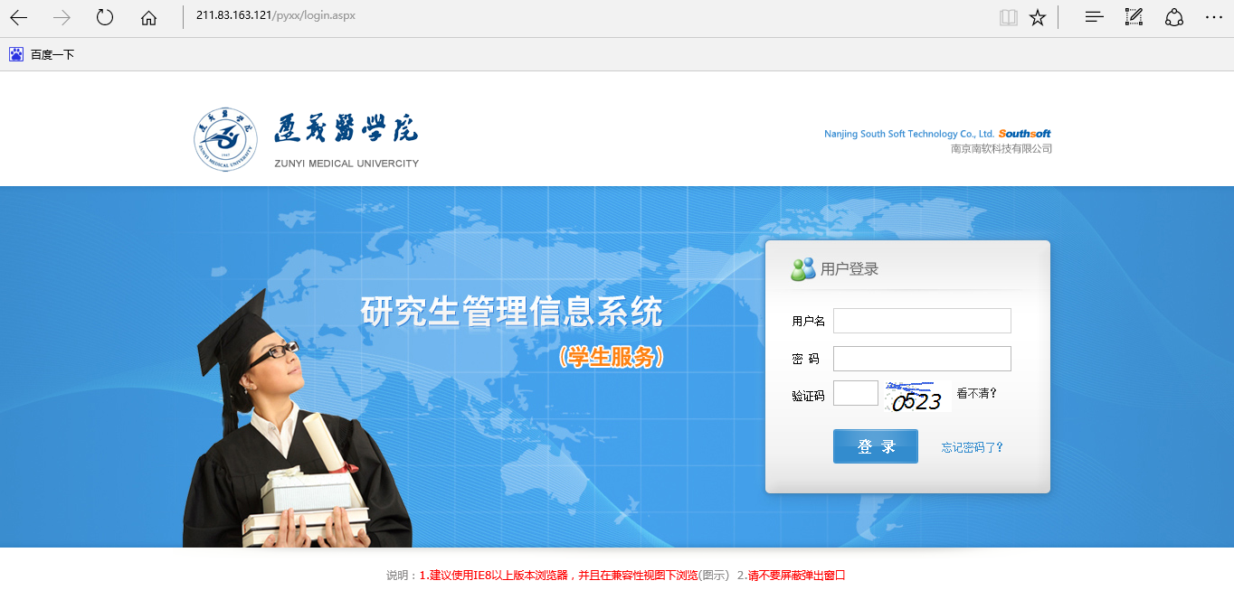
Figure 1.1 Login interface
图1.1 登陆界面
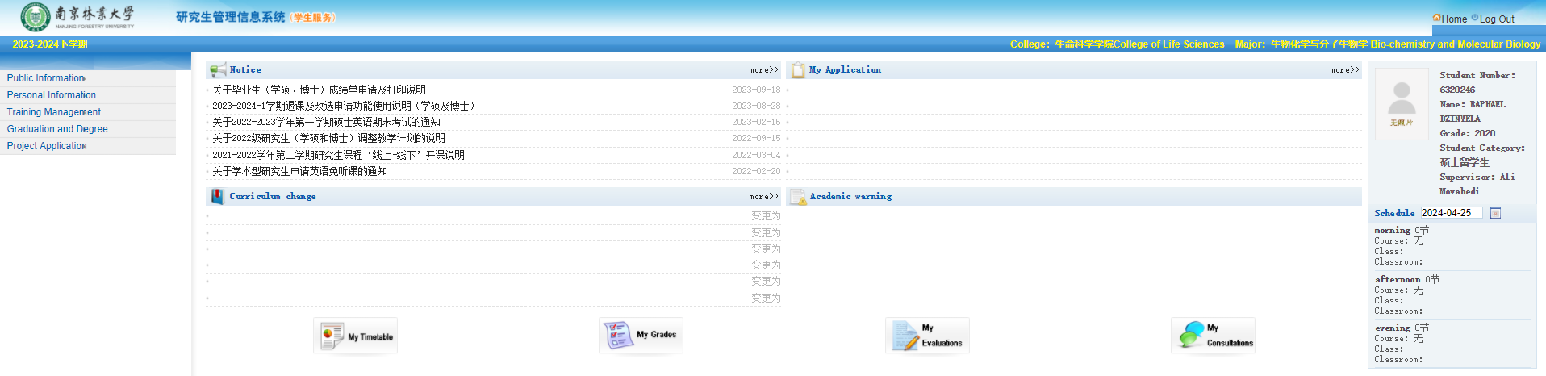
Figure 1.2 Main interface for students
图1.2 学生端界面

2 Public information

2公共信息

2.1 Master Training Program

2.1学历硕士培养方案
Function: View the information about Master’s training program
功能说明:查看学历硕士培养方案信息。
Instructions: Click 【Public Information】→【Training Program for Master Student】 to enter the student training program query interface as shown in Figure 2.1, then find the major according to the department and category, and click the name of the major, then jump to the information about Master's Degree Training Program, which is shown in Figure 2.2.
操作说明:点击【公共信息】→【学历硕士培养方案】，进入如图2.1所示，学生培养方案查询界面，按照院系，门类找到所属专业，点击专业字段，跳转入图2.2 所示的学历硕士培养方案信息。
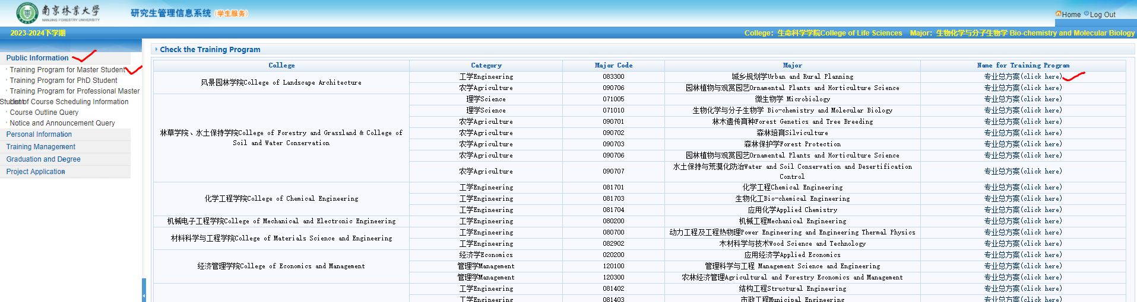
Figure 2.1 Training Program Query Interface
图2.1培养方案查询
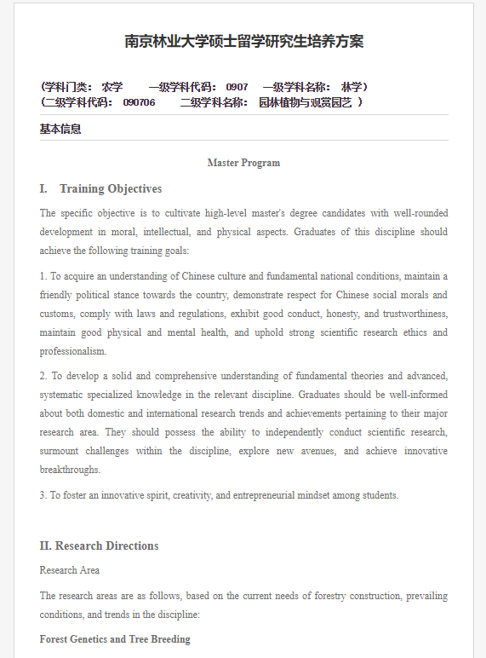
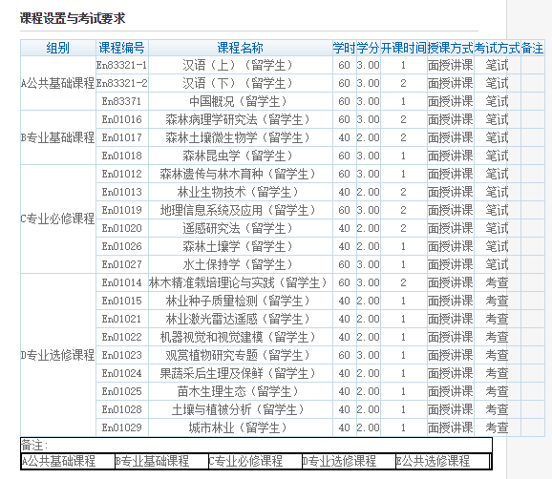
Figure 2.2 Information About Master's Degree Training Program
图2.2培养方案信息

2.2 Doctoral Training Program

2.2学历博士培养方案
Function: View the information about doctoral training program
功能说明:查询学历博士培养方案
Instructions: the same as 2.1.
操作说明:同2.1。

2.3 Professional Master Training Program

2.3专业学位培养方案
Function: Professional Master Training Program
功能说明: 专业学位培养方案
Instructions: the same as 2.1.
操作说明: 同2.1。

2.4 Course Arrangement Information

2.4课程排课信息一览
Function: to check whether the course is offered
功能说明:查询课程开课信息。
Instructions: Click 【Public Information】 → 【List of Course Scheduling Information】 to enter the query interface in Figure 2.3. Drop down to select semester, department or enter the course code, and click 【Query】 to browse the course arrangement information.
操作说明:点击【公共信息】→【课程排课信息一览】，进入图2.3查询界面。下拉选择学期，开课院系或者输入课程编号名称，点击【查询】，即可浏览课程排课信息。
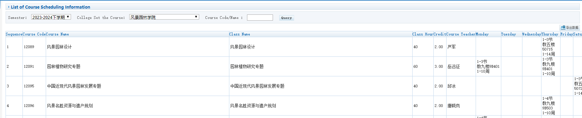
Figure 2.3 Information About Offering Courses
图2.3课程开课信息查询

2.5 Course Outline Query

2.5 课程大纲查询
Function: check information about course outline.
功能说明：查询课程大纲
Instructions: Click【Public Information】 → 【Course Outline Query】 to enter the query interface in Figure 2.4. Enter college as well as course code, click 【Query】, then click 【Download】to view the details for one course.
操作说明：点击【公共信息】→【课程大纲查询】，进入图2.4查询界面。输入学院及课程编号，点击【查询】，下载课程大纲即可进行查看。
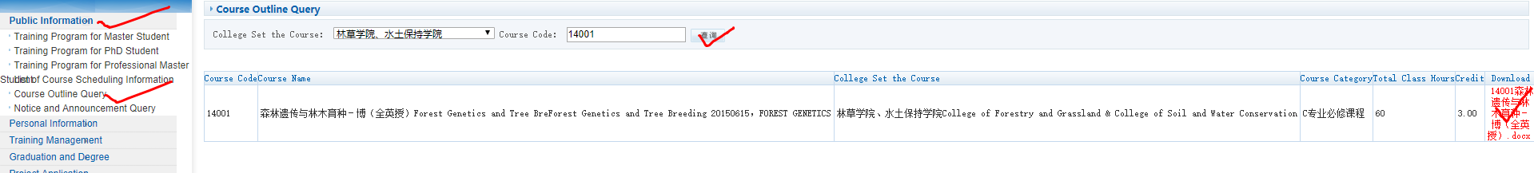
Figure 2.4 Query Interface for Course Outline
图2.4课程大纲查询

2.6 Check Announcement

2.6通知公告查询
Function: check information about announcements.
功能说明:查询公告通知信息。
Instructions: Click【Public Information】 → 【Notice and Announcement Query】 to enter the query interface in Figure 2.5. Enter keywords as well as publishing time and date, click 【Query】, and select publishing bulletin board in the announcement list, then click 【View Content】, and jump to interface 2.6 to view the details about announcement.
操作说明:点击【公共信息】→【通知公告查询】，进入图2.5查询界面。输入关键字以及发布时间日期，点击【查询】，在公告列表中选择发布公告栏，点击【查看】，跳转页面2.6，查阅公告详细信息。
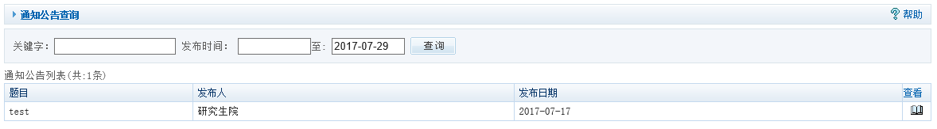
Figure 2.5 Query Interface for Announcement
图2.5通知公告查询
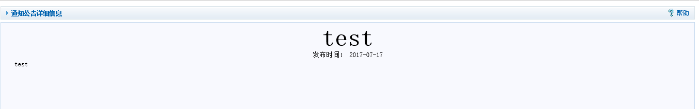
Figure 2.6 Details About Announcement
图2.6公告详情

3 Personal Information

3个人信息

3.1 Student Semester Registration

3.1学生学期注册
Function: Semester registration.
功能说明：学期注册。
Instructions: Click 【Personal Information】 → 【Semester Registration】 to enter the semester registration interface in Figure 3.1, and click【Submit Register】 to wait for approval. After the audit is completed, the audit status will change, as shown in Figure 3.2, and the button 【Submit Register】disappears, prompting that you have been registered. Note: Only within the allowed registration time can you submit the semester registration application.
操作说明：点击【个人信息】→【学生学期注册】，进入图3.1学期注册界面，点击【提交注册】，等待审核。待审核完成以后，则审核状态变为如图3.2所示，【提交注册】按钮也消失，提示已注册。注意：只有在允许注册时间范围能，才可以提交学期注册申请。
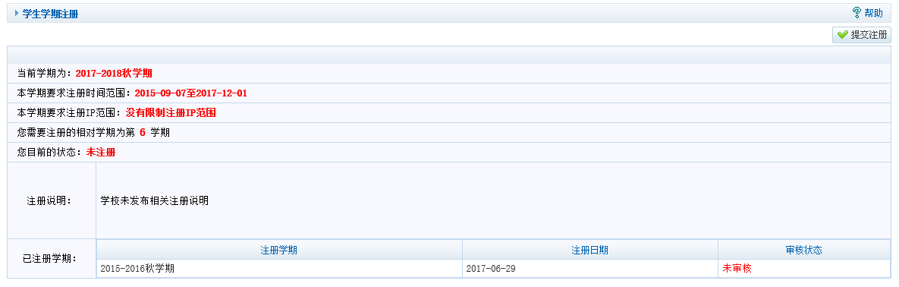
Figure 3.1 Semester registration
图3.1学期注册
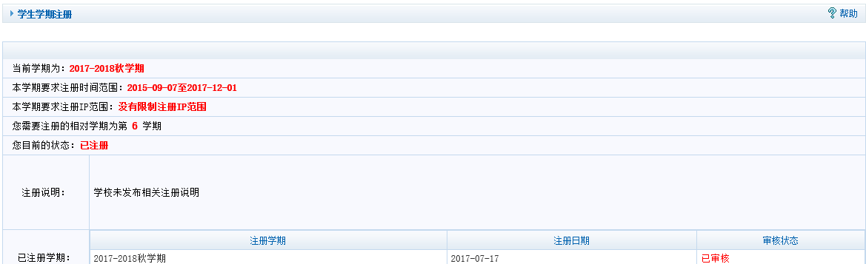
Figure 3.2 Semester registration successfully
图3.2学期注册成功

3.2 Basic Personal Information

3.2个人基本信息
Function: browsing personal information
功能说明：个人信息浏览。
Instructions: Click【Personal Information】 → 【Basic Personal Information】, and enter the interface as shown in Figure 3.3, then select the module in the upper column, and then browse the information of each module.
操作说明：点击【个人信息】→【个人基本信息】，进入如图3.3所示界面，选择上栏分区模块，选择浏览各个模块信息。
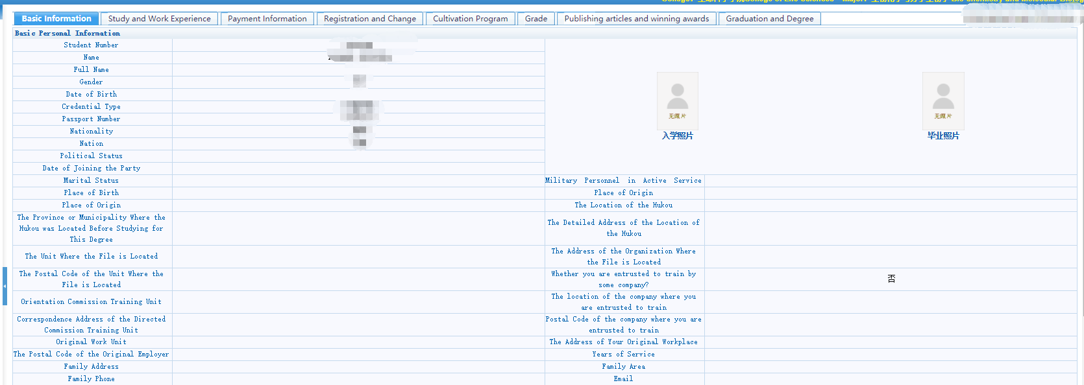
Figure 3.3 Personal Information
图3.3个人信息

3.3 Personal Information Editing

3.3个人信息修改
Function: Personal information modification.
功能说明：个人信息修改。
Instructions: Click 【Personal Information】 →【Personal Information Modification】 to enter the interface as shown in Figure 3.4. To edit the content, and click the save button【保存】in the upper right cornerto save.
操作说明：点击【个人信息】→【个人信息修改】，进入如图3.4页面。修改内容，点击【保存】。
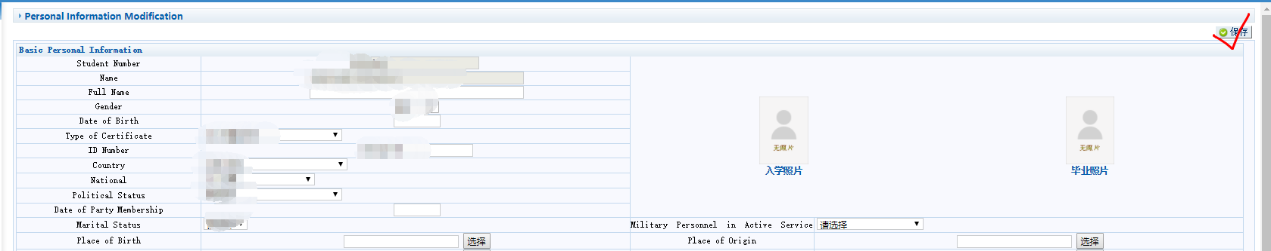
Figure 3.4 Personal Information Modification
图3.4个人信息修改

3.4 Application for Personal Key Information Modification

3.4个人关键信息修改申请
Function: Application for Personal Key Information Modification.
功能说明：关键信息修改申请。
Instructions: Click 【Personal Information】→【Application for Personal Key Information Modification】to enter the interface shown in Figure 3.5. Then select the item that needs to be edited from the drop-down, and fill in the modification content and reason, then click 【提交申请】to wait for approval.
操作说明：点击【个人信息】→【个人关键信息修改申请】，进入如图3.5所示页面，下拉选择修改项目名称，填写修改内容以及原因，点击【提交申请】，等待审核。
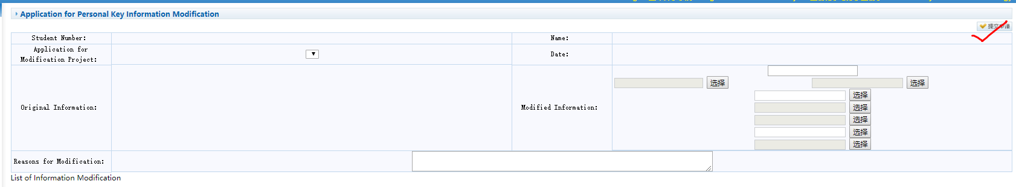
Figure 3.5 Application for Editing Key Information.
图3.5个人信息申请

3.5 Status-Change Application

3.5学籍异动申请
Function: Status-Change Application.
功能说明：学籍异动申请。
Instructions: Click 【Personal Information】→ 【Status-Change Application】to enter the interface in Figure 3.6. Fill in relevant information as required, and click "Submit Application", then waiting for review. You can only make the application during the time period when the school roll changes application is open, otherwise you will not be able to access the interface. For this part, if you have questions, please inquire the teaching secretary in College of International Education.
操作说明：点击【个人信息】→【学籍异动申请】，进入图3.6页面。按要求填写相关信息，点击【提交申请】，等待审核。只有在学籍异动申请开放的时间段，提出申请，否则无法进入页面。此部分操作，若有不清楚的地方，可至国教院研究生教学秘书处咨询。
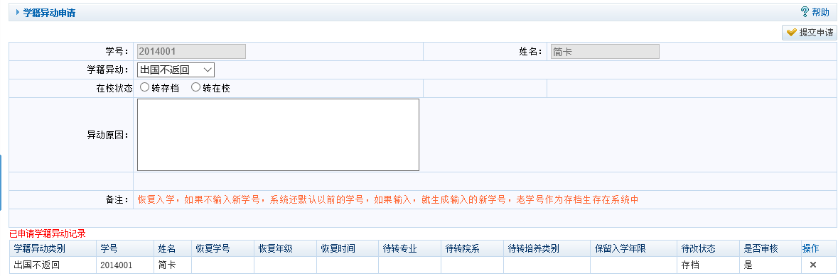
Figure 3.6 Status-Change Application
图3.6学籍异动申请

3.6 Postgraduate Enrollment Registration

3.6研究生入学登记
Function: Registration of postgraduate enrollment information.
功能说明：研究生入学信息等登记。
Instructions: Click 【Personal Information】 → 【Postgraduate Enrollment Registration】 to enter the interface as shown in Figure 3.7. Fill in the relevant contents and click【Submit】to complete the information entry.
操作说明：点击【个人信息】→【研究生入学登记】，进入如图3.7界面。填写相关内容，点击【提交】，完成信息录入。
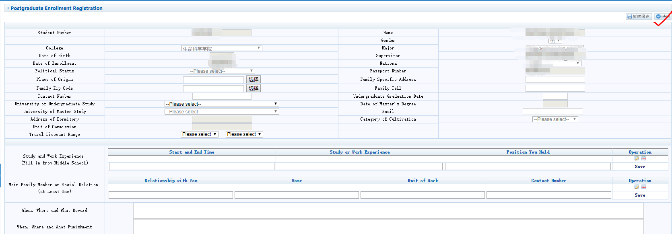
Figure 3.7 Enrollment
图3.7入学登记

3.7 Modification for Login Password

3.7登陆密码修改
Function: reset the login password.
功能说明：修改登录密码。
Instructions: Click 【Personal Information】 →【Modification for Login Password】 to enter the interface shown in Figure 3.8. Enter the new password and confirm it, and click 【Save】.
操作说明：点击【个人信息】→【登录密码修改】，进入图3.8及界面。输入新密码并确认，点击【保存】。
Figure 3.8 Password Modification
图3.8密码修改

3.8 Photo Information Check

3.8照片信息核对
Function: Check the photo
功能说明：核对照片信息。
Instructions: Click 【Personal Information】 → 【Photo Information Check】to enter the interface in Figure 3.9. If you find that the information is incorrect, contact the Management Office.
操作说明：点击【个人信息】→【照片信息核对】，进入图3.9页面。若发现信息有误，联系管理办。
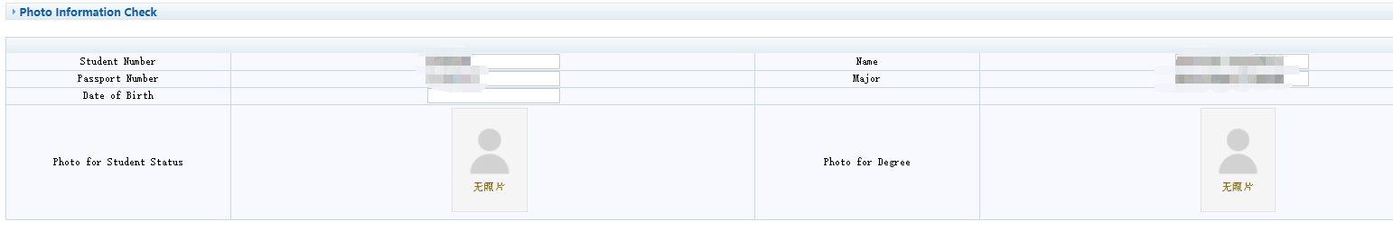
Figure 3.9 Photo Checking
图3.9照片信息核对

3.9 Registration for Grade Examination

3.9等级考试报名
Function: Grade examination registration.
功能说明：等级考试报名。
Instructions: Click 【Personal Information】 → 【Registration for Grade Examination】 to enter the interface in Figure 3.10. Select the subjects among the examination items that can be applied for, and click 【Apply】. Note: Photos and certificates cannot be blank. You can view the applied subjects by looking in the following column. This function can be only applied during special time period.
操作说明：点击【个人信息】→【等级考试报名】，进入图3.10页面。在可申请的考试项目中选择报考科目，点击【申请】。注意：照片及证件不能为空。在下栏中看可以查看已申请科目。本功能只能在特定时间段申请。
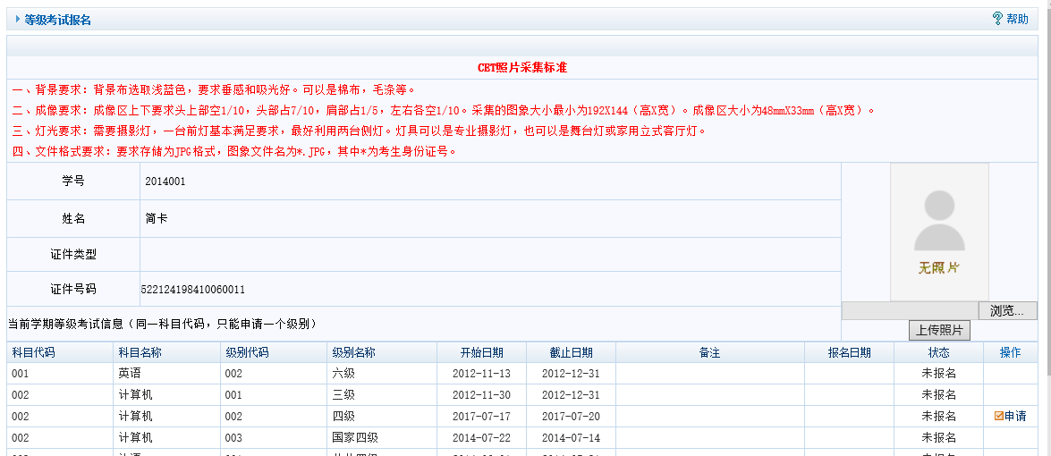
Figure 3.10 Registration of Grade Examination
图3.10等级考试报名

3.10 Grade Examination Results Query

3.10等级考试成绩查询
Function: check the grade examination score
功能说明：查询等级考试成绩。
Instructions: Click 【Personal Information】 → 【Grade Examination Results Query】to enter the interface of Figure 3.11, and browse the examination scores in the information column.
操作说明：点击【个人信息】→【等级考试成绩查询】，进入图3.11页面，在信息栏中即可浏览考试成绩信息。
Figure 3.11 Check Grade Examination Score
图3.11等级考试成绩查询

Explanation: For many contents of 【Personal Information】, no relevant operations are required unless there are special circumstances.
说明：【个人信息】板块，如无特殊情况，大部分内容无需进行相关操作。

4 Training Management

4培养管理

4.1 Teaching Plan Submission

4.1提交教学计划
Function: Submit the teaching plan
功能说明：提交培养计划。
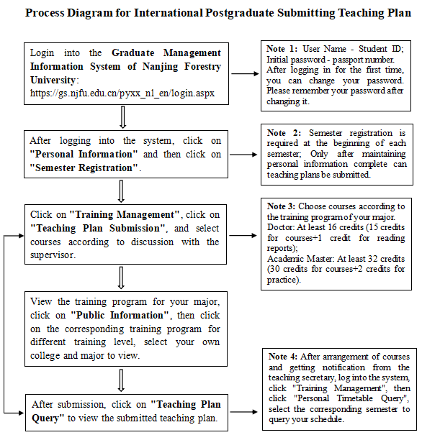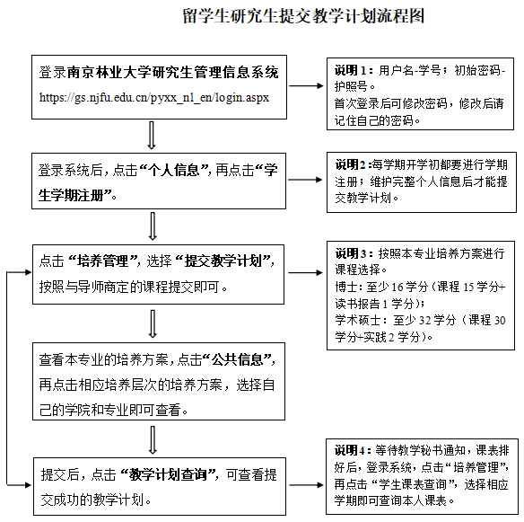
Figure 4.1 Process Diagram for Submitting Teaching Plan
图4.1 提交教学计划流程图
Instructions: Click 【Training Management】 → 【Teaching Plan Submission】 to enter the interface in Figure 4.2. Click【Add Non-degree Course】, as shown in Figure 4.3, and select colleges and departments, and then enter course code or name, click 【Query】. Select and add Non-degree Courses, and click【Submit Teaching Plan】, and wait for approval. Teaching plan can only be submitted during specific time period.
操作说明：点击【培养管理】→【提交教学计划】，进入图4.2页面。点击【添加非学位可课】，如图4.3所示，选择院系，输入课程编号或名称，点击【查询】，选择添加非学位课程，点击【提交教学计划】，等待审核。只能在特定时间段提交培养计划。
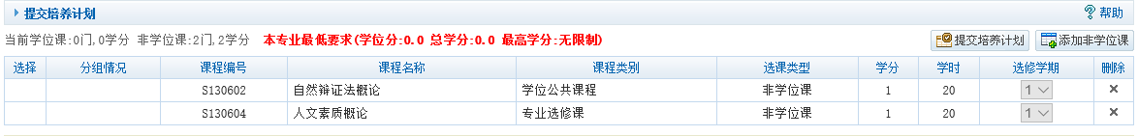 Figure 4.2 Teaching Plan Settings
图4.2教学计划设置
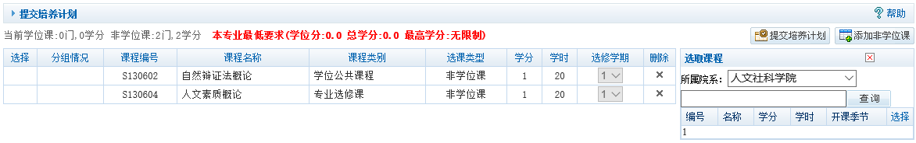
Figure 4.3 Adding non-degree courses
图4.3添加非学位课

4.2 Teaching Plan Query

4.2教学计划查询
Function: Check the training plan.
功能说明：查询培养计划。
Instructions: Click 【Training Management】 → 【Teaching Plan Query】 to enter the interface in Figure 4.4. Browse the training plan, then click 【Print】and jump to interface 4.5. Modify the format, and print the teaching plan table.
操作说明：点击【培养管理】→【教学计划查询】，进入图4.4页面。浏览培养计划信息，点击【打印】，跳转至4.5页面，修改格式信息，打印教学计划表。
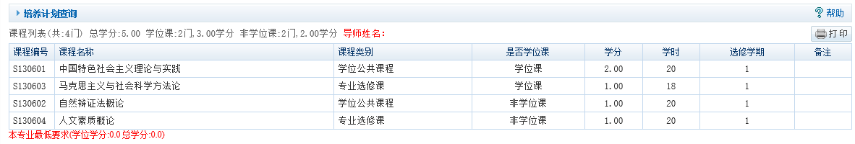
Figure 4.4 Teaching Plan Inquiry
图4.4教学计划查询
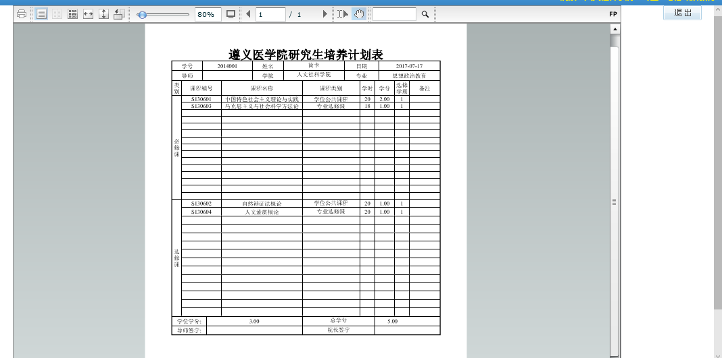
Figure 4.5 Training Plan Table Printing
图4.5计划表打印

4.3 Course Query

4.3开课目录查询
Function: check the courses that are available.
功能说明：查询开课课程。
Instructions: Click 【Training Management】→【Course Query】 to enter the interface in Figure 4.6. Select the college and department, and input course code or name. Click 【Query】, and browse the information in the list.
操作说明：点击【培养管理】→【开课目录查询】，进入图4.6页面，选择开课院系，课程编号或者名称，点击【查询】，在列表中浏览查询信息。

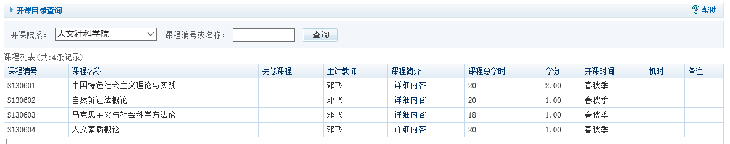
Figure 4.6 Enquiring List of Available Courses
图4.6开课目录查询

4.4 School Timetable Query

4.4全校课表查询
Function: check the courses that are available in the university.
功能说明：查询全校课表。
Instructions: the same as 4.3.
操作说明：同4.3。

4.5 Course Exemption Application

4.5课程免修申请
Function: apply for course exemption
功能说明：申请课程免修。
Instructions: Click 【Training Management】 →【Course Exemption Application】 to enter the interface in Figure 4.7. Select the subject that can be applied for, and enter the application reason, and then upload relevant documents before click 【Apply】. The status bar will change to the status of Applied and Unapproved. Note: Students can only apply during the period when they are allowed to apply for exemption, otherwise they cannot apply.
操作说明：点击【培养管理】→【课程免修申请】，进入图4.7界面。选择可申请的科目，输入申请理由，上传相关文件，点击【申请】，状态栏转为已申请，未审核状态。注意：学生只有在允许申请免修期间申请，否则无法申请。
图4.7课程免修申请
Figure 4.7 Application for Course Exemption

4.6 Courses Online Selection

4.6学生网上选课
Function: Online course selection.
功能说明：网上选课。
Instructions: Click 【Training Management】→ 【Courses Online Selection】 to enter Figure 4.8. The available class, applied class and optional class are distinguish by color. Click 【Select】, and the operation bar will be changed to the status of “Deselect”.
操作说明：点击【培养管理】→【学生网上选课】，进入图4.8。通过颜色区分开课、已选以及可选状态。点击【选课】，操作栏转为退选。
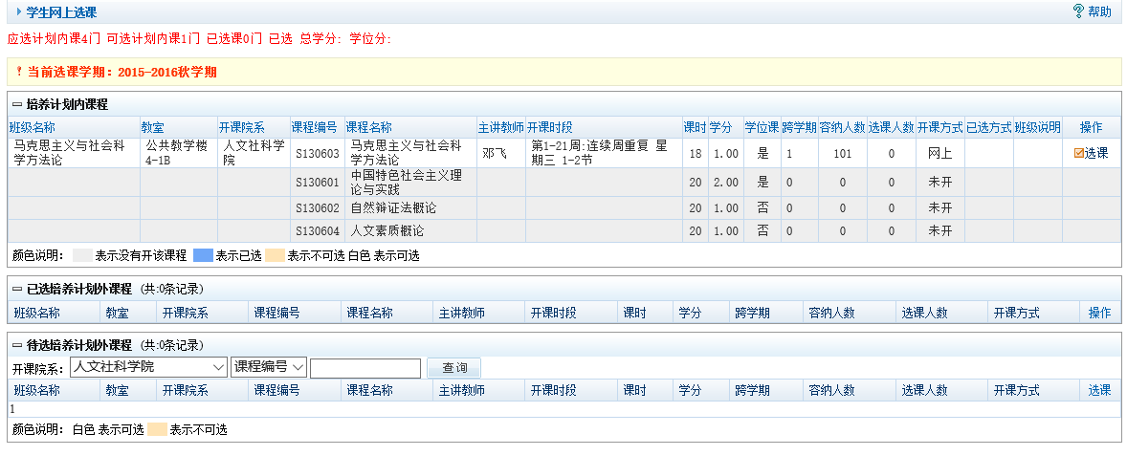
Figure 4.8 Students' online course selection
图4.8学生网上选课

4.7 Course Selection Result Query

4.7选课结果查询
Function: Course selection result query
功能说明：查询选课结果
Instructions: Click 【Training Management】 → 【Course Selection Result Query】to enter the interface in Figure 4.9. Drop down to select the semester and click 【Query】.
操作说明：点击【培养管理】→【选课结果查询】，进入图4.9页面。下拉选择学期，点击【查询】。
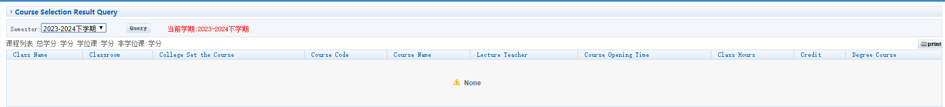
Figure 4.9 Result of course selection
图4.9选课结果

4.8 Personal Timetable Query

4.8学生课表查询
Function: the class timetable query
功能说明：查询课表。
Instructions: Click【Training Management】 → 【Personal Timetable Query】 to enter the interface in Figure 4.10. Drop down to select the semester and click【Query】. Click 【Print】 to jump to the interface in Figure 4.11 and print the timetable. Click 【Quit】 to exit printing.
操作说明：点击【培养管理】→【学生课表查询】，进入图4.10页面。下拉选择学期，点击【查询】。点击【打印】，跳转图4.11界面，打印课表。点击【退出】，退出打印。
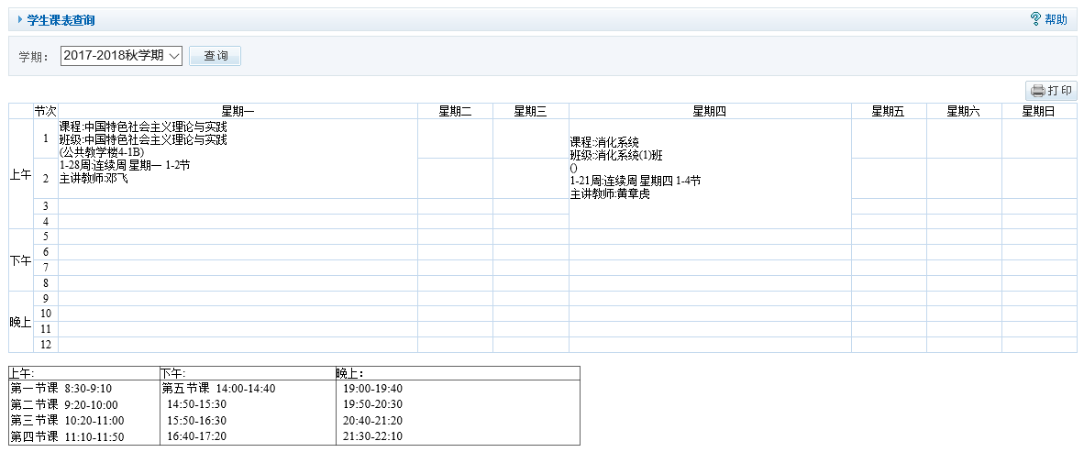
Figure 4.10 Timetable Query
图4.10课表查询
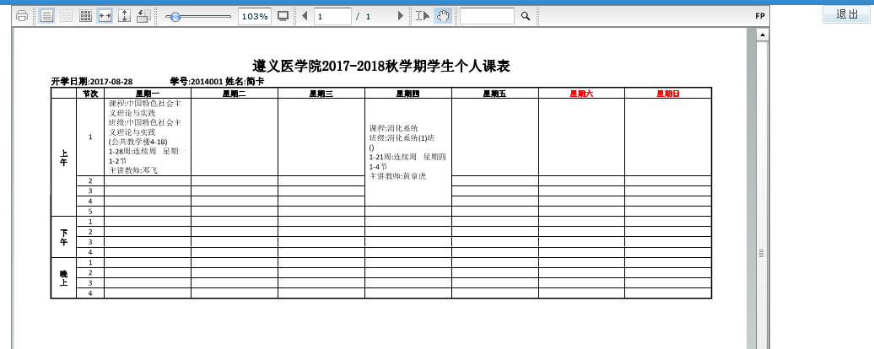
Figure 4. 11 Print the Timetable
图4.11打印课表

4.9 Personal Score Query

4.9学生成绩查询
Function: check students’ course score.
功能说明：查询学生成绩。
Instructions: Click 【Training Management】 → 【Personal Score Query】 to enter interface in figure 4.12. Click 【Print】 to download the transcript.
操作说明：点击【培养管理】→【学生成绩查询】，进入4.12页面。点击【打印】，下载成绩单。
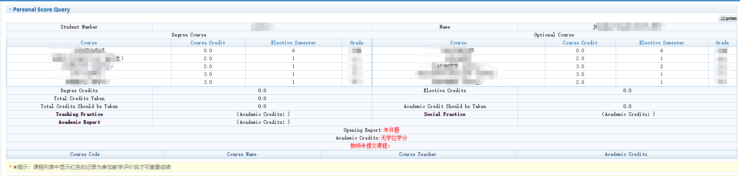
Figure 4.12 score query
图4.12成绩查询

4.10 Social Practice Registration

4.10社会实践登记
Function: social practice registration.
功能说明：社会实践信息登记。
Instructions: Click 【Training Management】 → 【Social Practice Registration】 to enter the interface of Figure 4.13. Enter the information as required, click 【Save】, and wait for approval. Click【Print】if need.
操作说明：点击【培养管理】→【社会实践登记】，进入图4.13页面。按要求输入信息，点击【保存】，等待审核。如需打印，点击【打印】。
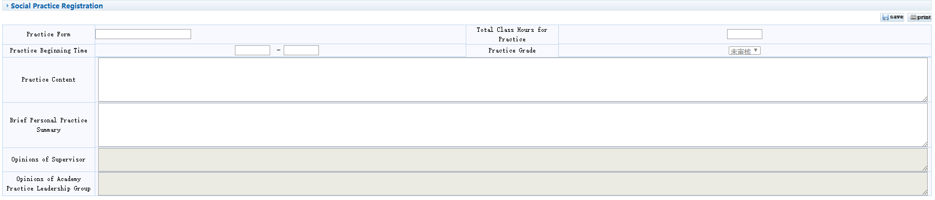
Figure 4.13 Social Practice Registration
图4.13社会实践登记

4.11 Teaching Practice Registration

4.11教学实践登记
Function: Teaching practice registration.
功能说明：教学实践登记。
Instructions: Same as 4.10.
操作说明：同4.10。

4.12 Input of Comprehensive Examination Score for PhD Student

4.12 博士综合考试成绩录入
Function: Input the comprehensive examination score for PhD student.
功能说明：录入博士综合考试成绩。
Instructions: Click 【Training Management】 → 【Input of Comprehensive Examination Score for PhD Student】 to enter the interface of Figure 4.14. Enter related information, score and exam committee members, then save and submit. Print the doctoral comprehensive examination score sheet and ask the members of the examination committee to sign. After signing, please submit the score sheet to your teaching college.
操作说明：点击【培养管理】→【博士综合考试成绩录入】，进入图4.14界面。录入考试成绩及考试委员会成员后保存并提交。打印博士综合考试成绩表，并找考试委员会成员签名，签名后请将成绩表交到所在学院。
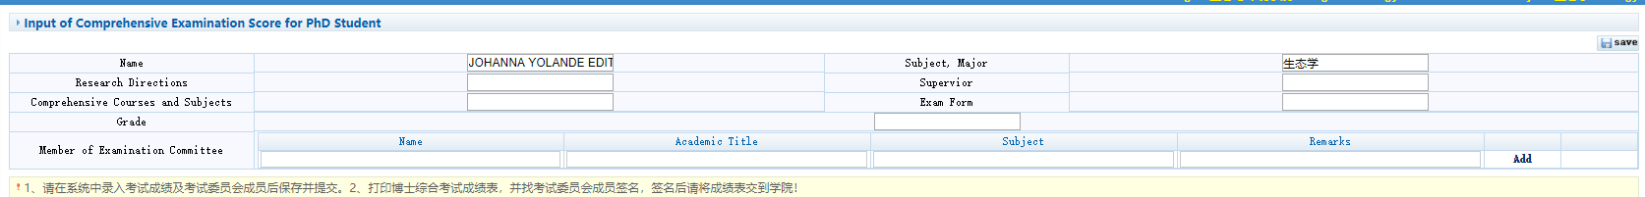
Figure 4.14 Input of Comprehensive Examination Score for PhD Student
图4.14录入博士综合考试成绩

4.13 Academic Activity Registration

4.13学术活动登记
Function: Registration of academic activities.
功能说明：学术活动登记。
Instructions: Click 【Training Management】 → 【Academic Activity Registration】 to enter the interface in Figure 4.15. Enter information and click【Add】to add records.
操作说明：点击【培养管理】→【学术活动登记】，进入图4.15界面。输入信息，点击【新增】，添加记录。
Figure 4.15 Registration of Academic Activities
图4.15学术活动登记

4.14 Academic Report Registration

4.14做学术报告登记
Function: Register academic reports.
功能说明：登记学术报告。
Instructions: Same as 4.10.
操作说明：同4.10。

4.15 Literature Reading Report Registration

4.15文献阅读报告登记
Function: Registration of Report About Literature Reading
功能说明：文献阅读报告信息登记。
Instructions: Same as 4.10.
操作说明：同4.10。

4.16 Mid-term Evaluation Registration

4.16中期考核登记
Function: Registration of mid-term evaluation.
功能说明：中期考核信息登记。
Instructions: Click 【Training Management】 →【Mid-term Evaluation Registration】to enter the interface of Figure 4.16. Enter relevant information, and click【Save】.
操作说明：点击【培养管理】→【中期考核登记】，进入图4.16页面，输入相关信息，点击【保存】。
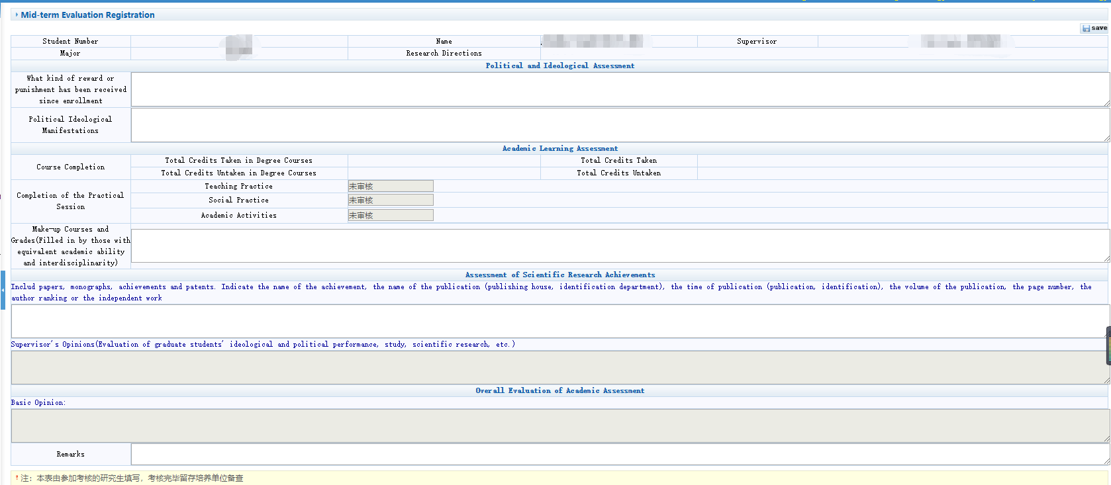Figure 4.16 Mid-term Evaluation Registration
图4.16中期考核登记

4.17 Course Adjustment and Suspension Information Query

4.17调停课信息查询
Function: Query the information of course adjustment and suspension.
功能说明：查询调停课信息。
Instructions: Click【Training Management】→【Course Adjustment and Suspension Information Query】 to enter interface 4.17.
操作说明：点击【培养管理】→【调停课信息查询】，进入4.17页面。
Figure 4.17 Query of Course Adjustment and Suspension
图4.17调停课信息查询

5 Graduation and Degree

5毕业与学位

5.1 Registration of Published Papers

5.1发表论文登记
Function: Registration of published papers.
功能说明：发表论文登记。
Instructions: Click 【Graduation and Degree】→【Registration of Published Papers】 to enter the interface in Figure 5.1. Enter relevant information, upload the cover of the paper, and click【Save】, and then wait for approval. In the paper list below, view the paper information and audit status. Click 【Print】 to print the list of papers.
操作说明：点击【毕业与学位】→【发表论文登记】，进入图5.1页面。输入相关信息，上传论文封面，点击【保存】，等待审核。在下方论文列表，查看论文信息以及审核状态。点击【打印】，打印论文表。
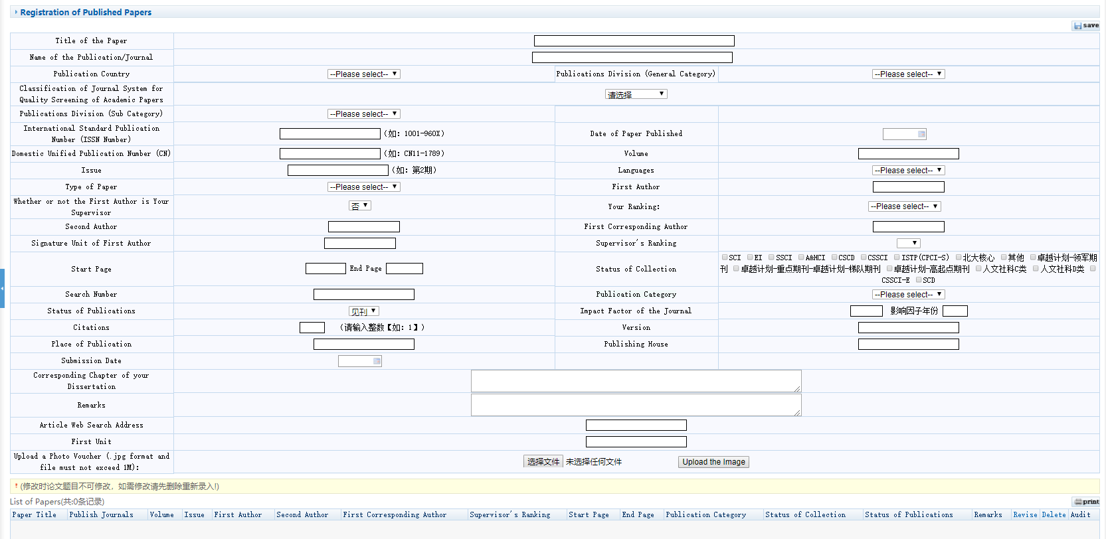
Figure 5.1 Registration of published papers
图5.1发表论文登记

5.2 Registration of Scientific Research Projects

5.2科研项目登记
Function: Registration of scientific research projects.
功能说明：科研项目登记。
Instructions: Click【Graduation and Degree】→【Registration of Scientific Research Projects】 to enter the interface in Figure 5.2. Enter relevant information and click【Save】. Query relevant information and audit status in the list of scientific research projects. Click【Print】to print the information of scientific research projects.
操作说明：点击【毕业于学位】→【科研项目登记】，进入图5.2 页面。输入相关信息，点击【保存】。在科研项目列表中查询相关信息，以及审核状态。点击【打印】，打印科研项目信息。
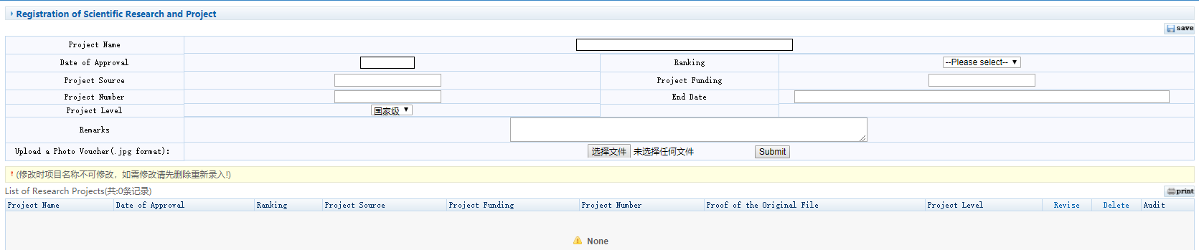
Figure 5.2 Registration of scientific research projects
图5.2科研项目登记

5.3 Patent Registration

5.3专利情况登记
Function: Patent registration.
功能说明：专利情况登记。
Instructions: Same as 5.1.
操作说明：同5.1。
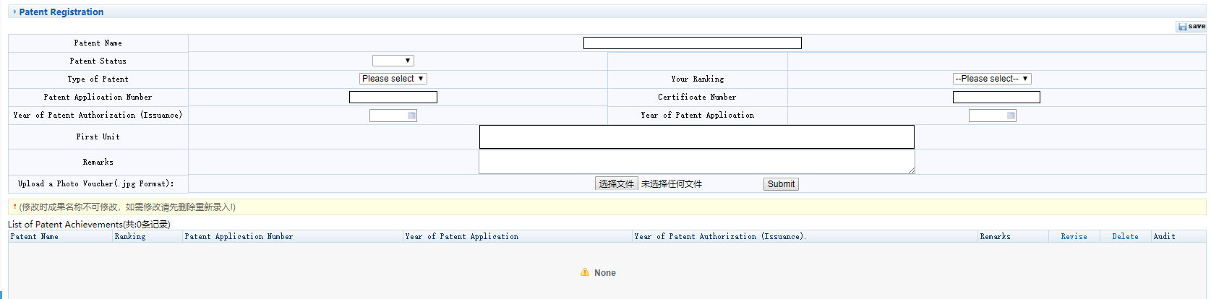
Figure 5.3 Patent registration
图5.3专利情况登记

5.4 Awarding Registration

5.4获奖情况登记
Function: Registration of awards.
功能说明：获奖情况登记。
Instructions: Same as 5.1.
操作说明：同5.1。
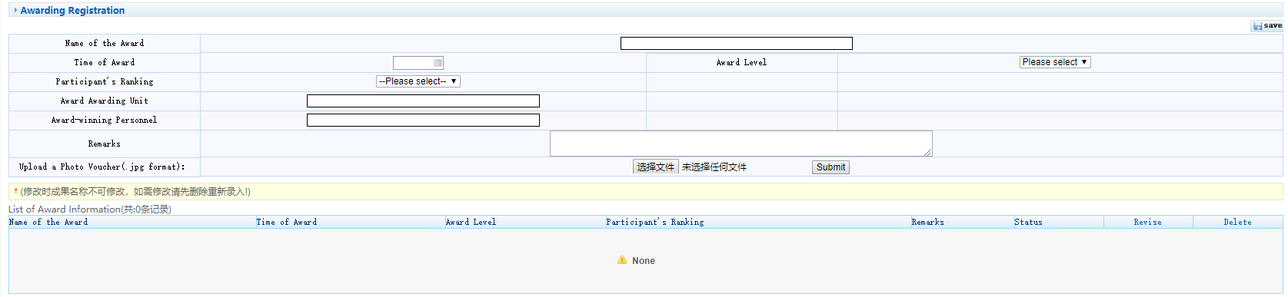
Figure 5.4 Registration of Awards
图5.4获奖情况登记

5.5 Registration of Research Achievement

5.5研究成果登记
Function: Registration of research achievements.
功能说明：研究成果登记。
Instructions: Same as 5.1.
操作说明：同5.1。
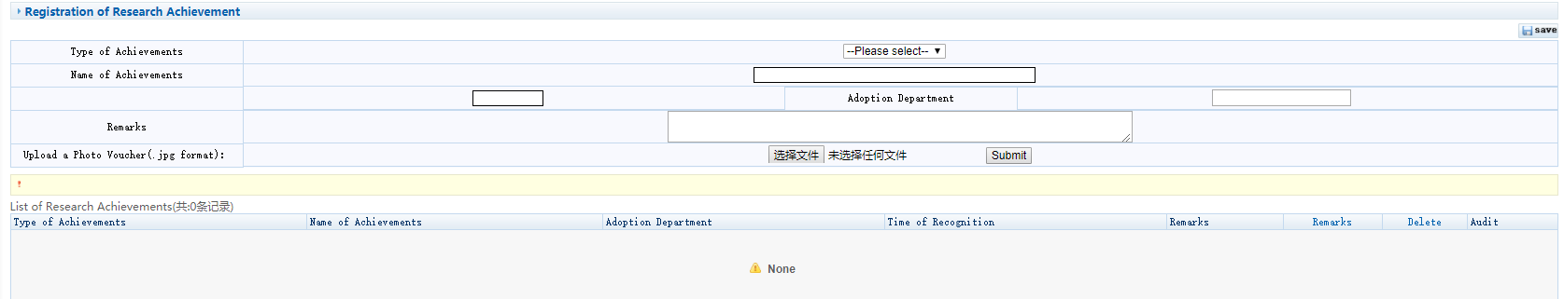
Figure 5.5 Registration of research results
图5.5研究成果登记

5.6 Opening Report Application

5.6开题报告申请
Function: Application for thesis proposal/opening report.
功能说明：申请开题报告。
Instructions: Click【Graduation and Degree】→【Opening Report Application】 to enter the interface in Figure 5.6. Enter related information, upload your thesis proposal/opening report and click 【Submit】, then Click 【Submit】 in the upper right corner.
操作说明：点击【毕业与学位】→【开题报告申请】，进入图5.6页面。输入信息，上传开题报告，点击【提交】，最后点击右上角的【提交】。
The format template for the thesis proposal/opening report can be found at: https://ieceng.njfu.edu.cn//ACADEMICS/Postgraduates/Downloads/20220324/i249565.html
开题报告的格式模板参见：
https://ieceng.njfu.edu.cn//ACADEMICS/Postgraduates/Downloads/20220324/i249565.html
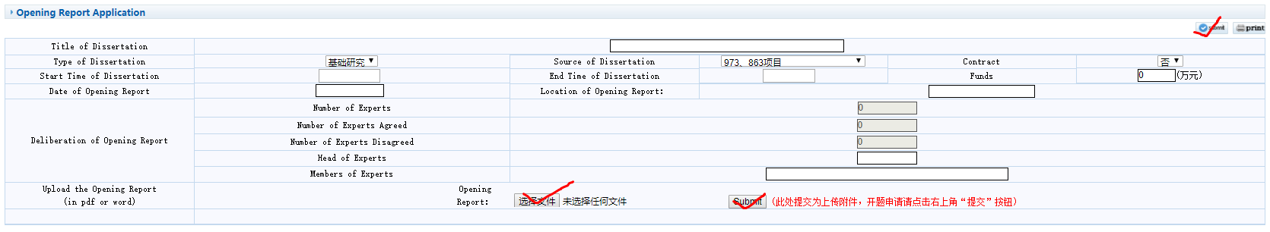
Figure 5.6 Application for thesis proposal
图5.6开题报告申请

5.7 Opening Report Result Input

5.7开题结果录入
Function: Enter the result of thesis proposal/opening report.
功能说明：录入开题结果。
Instructions: Same as 5.6. Note: The result can only be entered after the faculty secretary approves it.
操作说明：同5.6。注意：只有当院系秘书审核通过后，才能录入结果信息。

5.8 Application for Changing Research Topic

5.8 学生换题申请
Function: Apply to change the title of the thesis.
功能说明：申请更换论文题目。
Instructions: Click【Graduation and Degree】→【Application for Changing Research Topic】 to enter the interface in Figure 5.7. Input related information, click【Submit】→【Print】, then wait for the approve of current supervisor, dean in charge of the college, and graduate school.
操作说明：点击【毕业与学位】→【学生申请换题】，进入图5.7页面。输入信息，点击【提交申请】和【打印】，提交申请后，需现导师、学院分管院长以及研究生院审核通过。
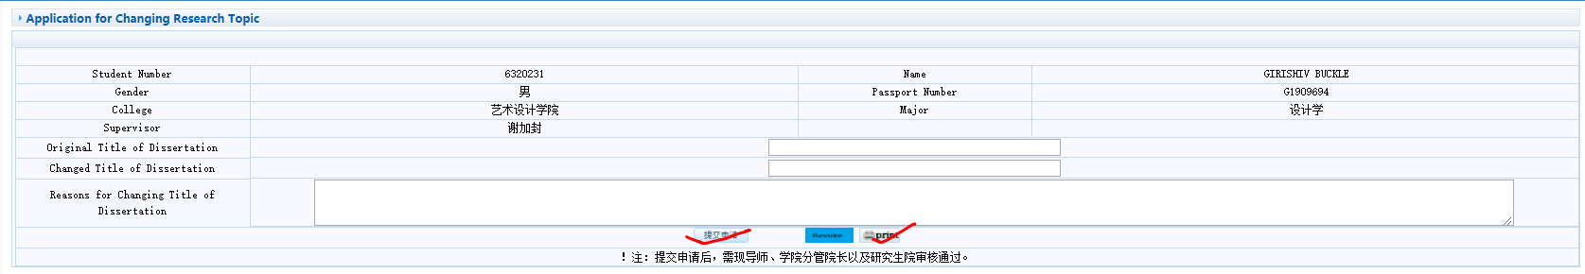
Figure 5.7 Application for changing research topic
图5.7 换题申请

5.9 Pre-defense for PhD Student

5.9 博士预答辩
Function: Application and input of pre-defense for PhD student.
功能说明：博士预答辩的申请及结果录入。
Instructions: Click【Graduation and Degree】→【Pre-defense for PhD Student】to enter the interface in Figure 5.8. Before pre-defense, input related information and Supervisor's comments, click 【Save】, after confirming that there are no errors, click【Submit】; After pre-defense, input the conclusion from the Pre-defense committee, then click 【Save】, after confirming that there are no errors, click【Submit】.
操作说明：点击【毕业与学位】→【博士预答辩】，进入图5.8页面。预答辩之前，输入相关信息及导师意见，点击【保存】，确认无误后点击【提交】；预答辩之后，录入结果，再点击【保存】，确认无误后点击【提交】。
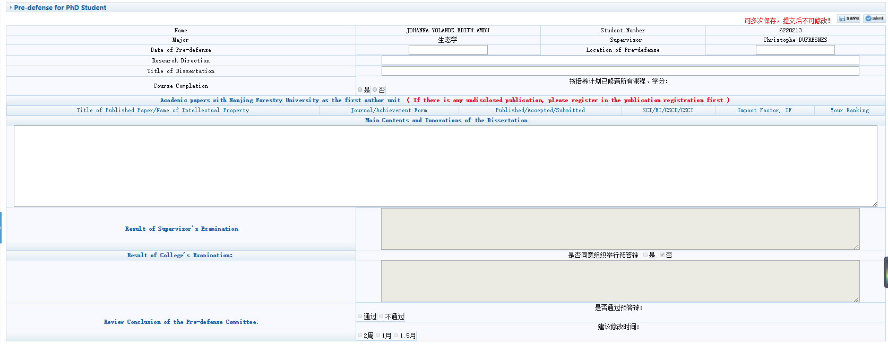
Figure 5.8 Pre-defense for PhD Student
图5.8 博士预答辩

5.10 Application for Dissertation Repetition Rate Query

5.10 论文查重申请
Function: Apply to check the repetition rate of thesis.
功能说明：申请查询论文重复率。
Instructions: Click【Graduation and Degree】→【Application for Dissertation Repetition Rate Query】to enter the interface in Figure 5.9. Upload the thesis in blind review version to check repetition rate. The layout of degree dissertation can be found at: https://ieceng.njfu.edu.cn//ACADEMICS/Postgraduates/Downloads/20220324/i249573.html
操作说明：点击【毕业与学位】→【论文查重申请】，进入图5.9页面。上传盲审版格式的论文进行查重。学位论文排版格式参见：
https://ieceng.njfu.edu.cn//ACADEMICS/Postgraduates/Downloads/20220324/i249573.html
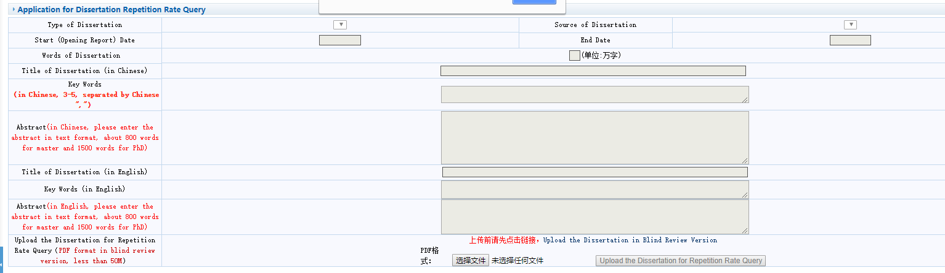
Figure 5.9 Application for Dissertation Repetition Rate Query
图5.9 论文查重申请

5.11 Result of Dissertation Repetition Rate Query

5.11 论文查重结果
Function: Check the result of repetition rate of thesis.
功能说明：查询论文查重结果。
Instructions: Click【Graduation and Degree】→【Result of Dissertation Repetition Rate Query】to enter the interface in Figure 5.10. Download the report to check the details.
操作说明：点击【毕业与学位】→【论文查重结果】，进入图5.10页面。下载查重报告查看细节。
Figure 5.10 Result of Dissertation Repetition Rate Query
图5.10 论文查重结果

5.12 Registration for Dissertation Blind Review

5.12 学生盲审登记
Function: Check the result of repetition rate of thesis.
功能说明：盲审登记。
Instructions: Click【Graduation and Degree】→【Registration for Dissertation Blind Review】to enter the interface in Figure 5.11. Input related information and upload the thesis and abstract according to the requirements.
操作说明：点击【毕业与学位】→【学生盲审登记】，进入图5.11页面。录入相关信息，按照要求上传论文和摘要。
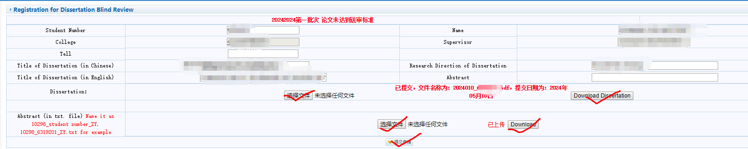
Figure 5.11 Registration for Dissertation Blind Review
图5.11 学生盲审登记

5.13 Result of Dissertation Blind Review

5.13学生盲审查询
Function: blind review results inquiry
功能说明：查询盲审结果。
Instructions: Click 【Graduation and Degree】→【Result of Dissertation Blind Review】 to enter the interface in Figure 5.12, and browse the blind review results.
操作说明：点击【毕业与学位】→【学生盲审查询】，进入图5.12页面。浏览盲审结果。
Figure 5.12 Students' blind peer review results
图5.12学生盲审结果

5.14 Verification of Degree Conferring Data

5.14学位授予数据核对
Function: check the degree conferring data.
功能说明：学位授予数据核对。
Instructions: Click 【Graduation and Degree】→【Verification of Degree Conferring Data】 to enter the interface in Figure 5.13. Check and edit the data and click 【Save】.
操作说明：点击【毕业与学位】→【学位授予数据核对】，进入图5.13页面。核对修改数据，点击【保存】。
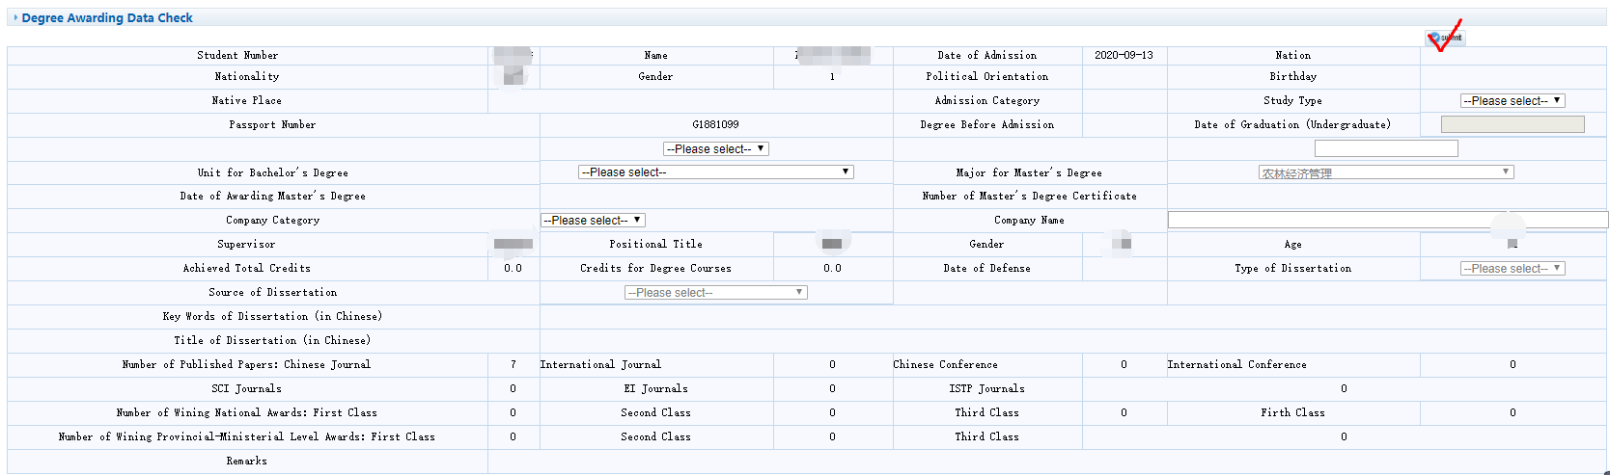
Figure 5.13 Data Verification
图5.13数据核对

5.15 Application for Final Defense

5.15学生答辩申请
Function: defense application.
功能说明：答辩申请。
Instructions: Click 【Graduation and Degree】→【Application for Final Defense】 to enter the interface in Figure 5.14. Enter the information and click 【Save】. Click 【Print】 to print the defense application form. Note: Students applying for defense must meet the requirements of application for defense, otherwise they can not apply.
操作说明：点击【毕业与学位】→【学生答辩申请】，进入图5.14页面。输入信息，点击【保存】。点击【打印】，打印申请答辩表。注意：学生申请答辩，需满足申请答辩要求，否则不可申请。
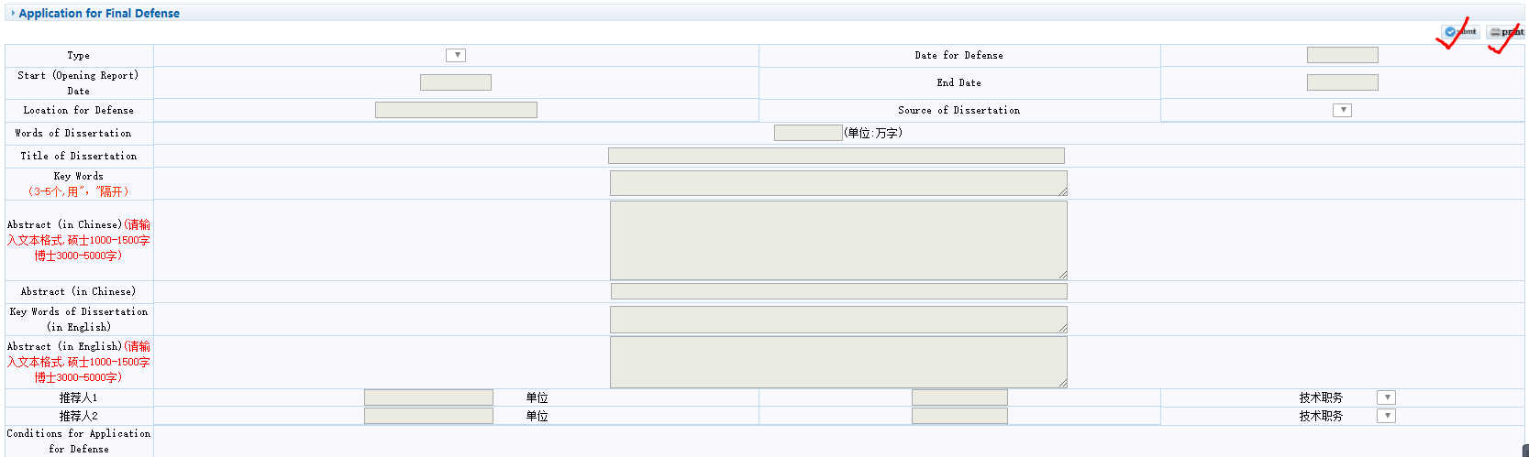
Figure 5.14 Defense application
图5.14答辩申请

5.16 Submission of Final Dissertation

5.16上传答辩学位论文
Function: Submit the final dissertation.
功能说明：上传学位论文。
Instructions: Click 【Graduation and Degree】→【Submission of Final Dissertation】 to enter the interface in Figure 5.15. Enter the information, upload the dissertation. Click 【Save the information】 to submit the dissertation. Note: Only after the defense is passed can the dissertation be uploaded.
操作说明：点击【毕业与学位】→【上传学位论文】，进入图5.15页面。输入信息，点击【浏览】，上传论文。点击【保存最终论文信息】，提交学位论文。注意：只有答辩通过后才能上传学位论文。
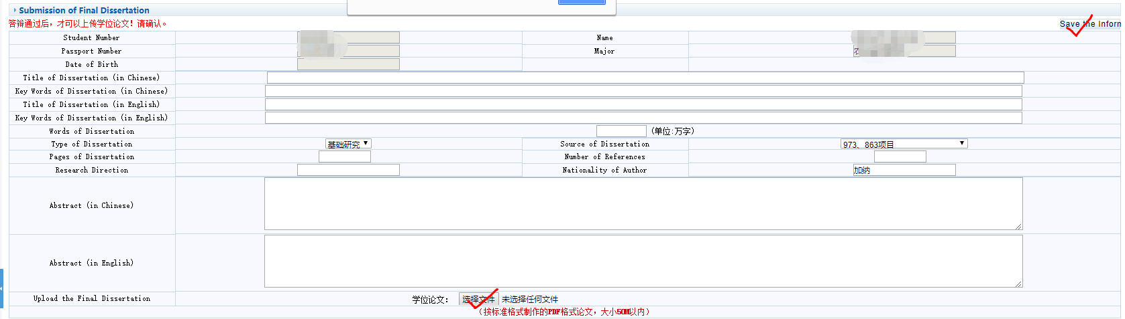
Figure 5.15 Submit the dissertation
图5.15上传学位论文

5.17 Application for Early Graduation

5.17 提前毕业申请
Function: Apply to early graduation.
功能说明：申请提前毕业。
Instructions: Click 【Graduation and Degree】→【Application for Early Graduation】 to enter the interface in Figure 5.16. Enter the information, click 【Save】and 【Print】.
操作说明：点击【毕业与学位】→【提前毕业申请】，进入图5.16页面。输入信息，点击【保存】和【打印】。
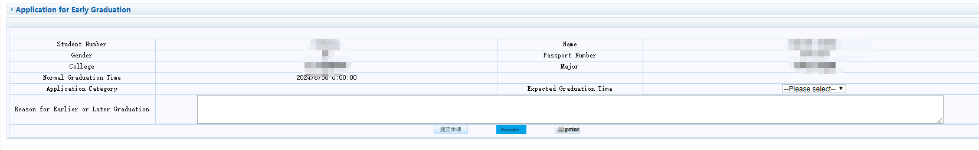
Figure 5.16 Apply to early graduation
图5.16申请提前毕业

5.18 Application for Postponing Graduation

5.18 延期毕业申请
Function: Apply to post graduation.
功能说明：申请延期毕业。
Instructions: Same as 5.17.
操作说明：同5.17。

5.19 Personal Files Query

5.19 学生档案材料查询
Function: Check personal files.
功能说明：查询学生档案材料。
Instructions: Click 【Graduation and Degree】→【Personal Files Query】 to enter the interface in Figure 5.17 to check personal files.
操作说明：点击【毕业与学位】→【学生档案材料查询】，进入图5.17页面，查询档案材料。
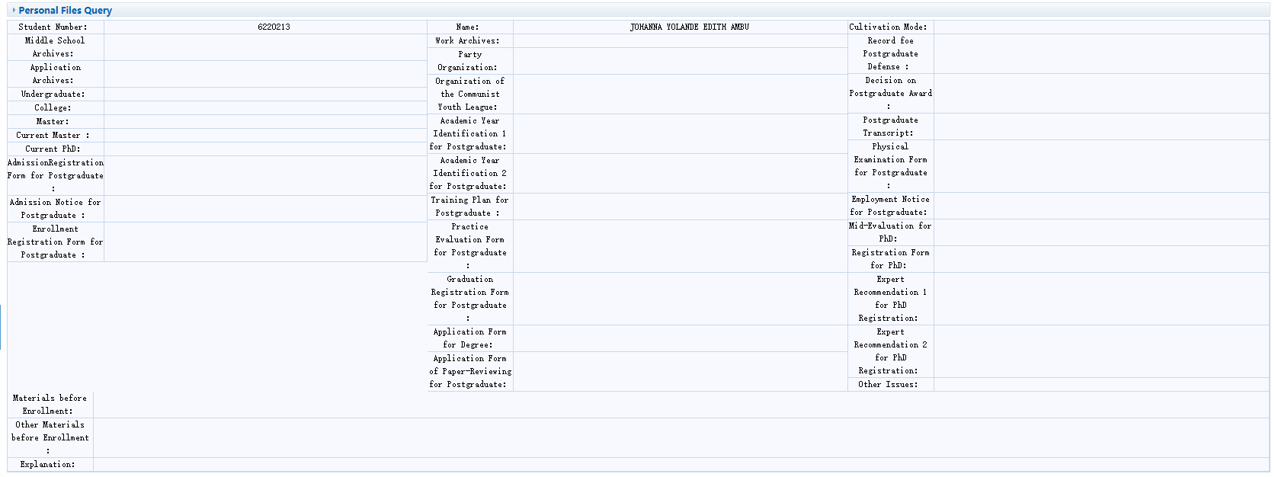
Figure 5.17 Personal Files Query
图5.17档案材料查询

6 Project Application

6 项目申请

6.1 Application for Provincial Innovation Plan

6.1 省创新计划申请
Function: Apply the provincial innovation plan.
功能说明：申请省创新计划。
Instructions: Click 【Project Application】→【Application for Provincial Innovation Plan】 to apply plan. The plan can only be applied for within the specified time.
操作说明：点击【项目申请】→【省创新计划申请】申请计划项目。只有在规定时间内才能申请该项。

