Login the system:

<https://gs.njfu.edu.cn/pyxx_nl_en/login.aspx>

User Name: Student number

Password: Passport number (current or previous)

## Click [Training Management] and [Personal Score Query], then click [Print], your transcript will be downloaded. Take your transcript to College of International Education, Room 209 to get stamp.

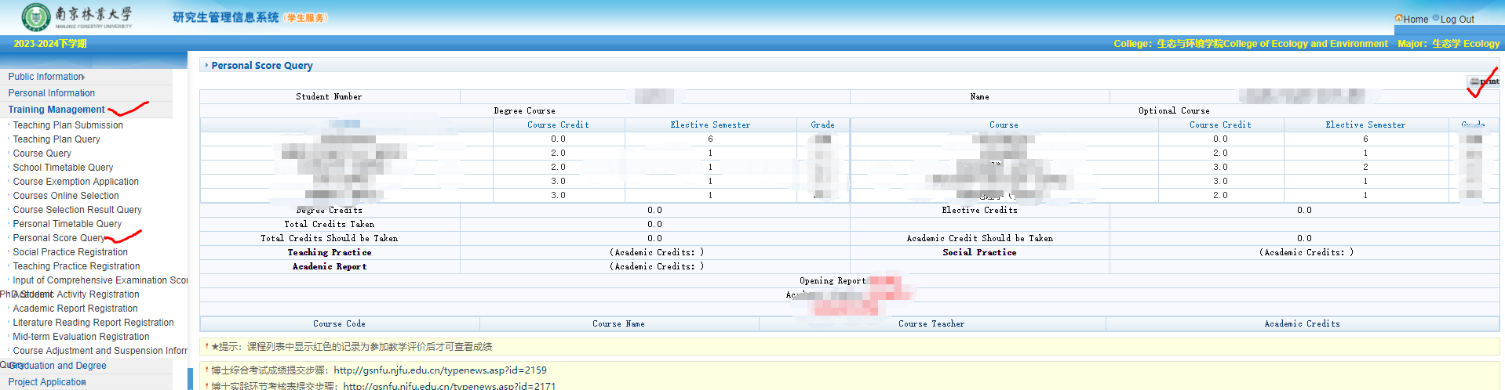

## **学生成绩查询**

Function: check students’ course score.

功能说明：查询学生成绩。

Instructions: Click 【Training Management】 → 【Personal Score Query】 to enter interface in figure 4.12. Click 【Print】 to download the transcript.

操作说明：点击【培养管理】→【学生成绩查询】，进入4.12页面。点击【打印】，下载成绩单。